ORTHOPAEDIC INSTRUMENTS
Bone Cutters & Nibblers
Bone Cutting Forceps
Intended Use
Bone cutting forceps are double-action orthopaedic cutting instruments indicated for dividing, trimming and resecting bone during trauma surgery, osteotomy, amputation, bone-graft harvesting and arthroplasty in veterinary patients. They allow the surgeon to remove bony prominences, shorten fragments and shape bone ends precisely before fracture fixation or implant placement. | 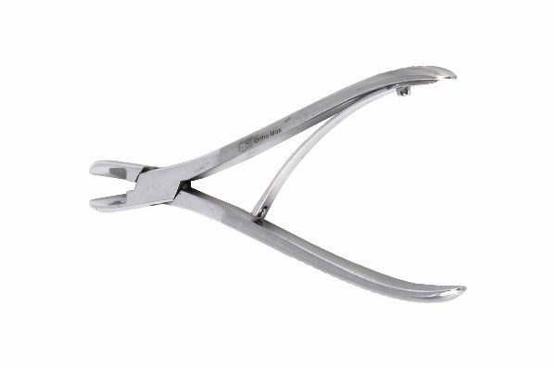
Function
Forged from hardened surgical-grade stainless steel, the instrument carries two sharp, opposing blades driven through a double-action pivot mechanism that multiplies applied hand force. When the handles are closed, the blades meet edge-to-edge, shearing bone cleanly without crushing surrounding tissue or creating large bone debris fields.
Advantages
Force Multiplication: The double-action mechanism converts modest hand effort into powerful cutting force, letting surgeons divide dense diaphyseal cortex of large breed dogs without excessive hand fatigue even in prolonged orthopaedic procedures.
Clean Resection Margins: Precisely ground mating blades shear bone sharply, leaving smooth edges that promote better contact healing and reduce the bone-fragment debris that must be irrigated away before implant placement.
FAQ
Q: What is the difference between single-action and double-action bone cutters?
A: A double-action cutter has two pivots that multiply applied force, giving greater cutting power and finer control; single-action cutters are simpler but require more hand strength for dense cortical bone.
Q: How should the blades be maintained?
A: Inspect cutting edges after every sterilisation cycle; dull or nicked blades crush rather than cut bone and must be resharpened or the instrument replaced.

ORTHOPAEDIC INSTRUMENTS
Bone Cutters & Nibblers
Bone Nibblers
Intended Use
Bone nibblers are double-action rongeur-type instruments used to nibble away small bites of bone in veterinary orthopaedics, neurosurgery and spinal procedures. They are ideal for refining fracture fragment edges, removing bone spurs, performing spinal decompression laminectomy and preparing graft sites in dogs and cats. | 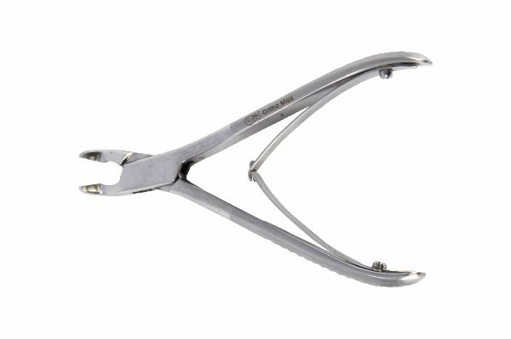
Function
The instrument's cupped, sharp-rimmed jaws close through a double-action hinge that multiplies grip strength, biting off precise bone fragments with each squeeze. A self-opening spring returns the jaws after each bite, allowing rapid repetitive nibbling. The debris cup retains each fragment, reducing contamination of the surgical field.
Advantages
Controlled Piecemeal Removal: Small, repeatable bites give millimetre-level control over bone resection, ideal for delicate procedures near spinal cord, articular cartilage or neurovascular structures where bulk cutting instruments cannot be used safely.
Reduced Hand Fatigue: Double-action leverage and self-opening spring handles let the surgeon nibble dense bone for prolonged periods without fatigue, important in complex spinal decompression cases requiring extensive bone removal.
FAQ
Q: How does a bone nibbler differ from bone cutting forceps?
A: A nibbler removes bone in small successive bites for fine sculpting, whereas cutting forceps divide bone in a single stroke — both are used together in most complex orthopaedic cases.
Q: When are bone nibblers preferred in fracture surgery?
A: They excel at freshening fracture margins, removing callus and trimming irregular edges so plates and implants seat flush against the bone surface for stable fixation.

ORTHOPAEDIC INSTRUMENTS
Bone Cutters & Nibblers
Sargent Rongeur D-A Big
Intended Use
The Sargent rongeur double-action big is a heavy-duty bone-biting instrument used in large veterinary orthopaedic and spinal procedures requiring rapid removal of substantial bone volumes. It is indicated for laminectomy, vertebral body decompression and removal of large cancellous bone masses in large breed dogs and equine patients. | 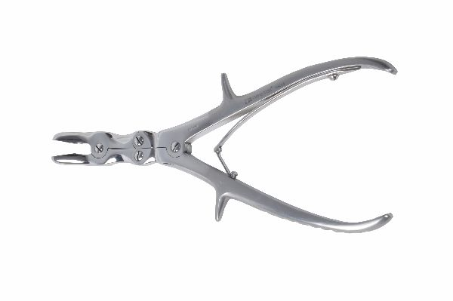
Function
Extra-large, sharp-rimmed, oval cupped jaws meet precisely under the force-multiplying action of a twin-pivot linkage, scooping out generous bone bites per squeeze. The extended handle length increases mechanical advantage, allowing adequate cutting force even through dense cortical bone of large animal long bones.
Advantages
High-Volume Bone Removal: The large cup dimensions and reinforced double-action mechanism allow rapid bone removal in bulky procedures, shortening operative time significantly compared with smaller rongeurs in large breed spinal or long bone procedures.
Effective Debridement: Sharp cup rims excise necrotic and infected bone back to healthy bleeding margins — a key step in osteomyelitis sequestrectomy and infected implant bed preparation in veterinary orthopaedics.
FAQ
Q: What procedures suit the Sargent big rongeur?
A: Laminectomy, fracture-edge preparation, sequestrectomy, biopsy harvesting and cortical windowing for intramedullary nail insertion in large and giant breed dogs.
Q: How is jaw sharpness preserved?
A: Avoid twisting while biting, clean cup debris promptly, and have rims professionally re-sharpened when bite sizes decrease despite full jaw closure.

ORTHOPAEDIC INSTRUMENTS
Bone Cutters & Nibblers
Strong Bone Cutter
Intended Use
The strong bone cutter is a heavy-duty, double-action cutting instrument indicated for dividing thick cortical bone in large and giant breed dog fracture cases, equine orthopaedics and large animal amputation procedures. It provides the cutting power required when standard forceps would stall against dense diaphyseal cortex. | 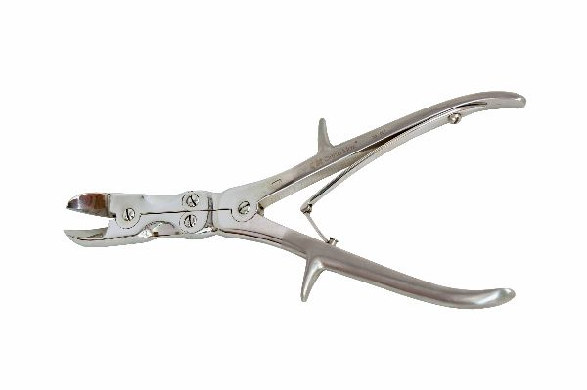
Function
Massive straight cutting blades, forged and hardened from premium surgical stainless steel, close through a reinforced double-action linkage with extended lever handles. The geometry maximises mechanical advantage, transmitting hand force into blade-edge shear stress sufficient to section fully the femoral diaphysis of large breed patients.
Advantages
Maximum Cutting Power: Reinforced double-action leverage with long handles divides thick cortical bone that would stall lighter instruments, making this cutter the preferred choice in large dog and equine amputation or osteotomy procedures.
Durable Heavy-Gauge Build: Oversized pivots and hardened blades maintain edge alignment under extreme load, ensuring a long service life even in frequent, demanding large animal surgical environments.
FAQ
Q: When is the strong cutter chosen over an oscillating saw?
A: For quick cold division of bone without thermal necrosis risk, in settings where power equipment is unavailable, or where the cutting geometry does not allow saw-blade access.
Q: Does heavy cutting damage surrounding bone?
A: A sharp, well-aligned cutter shears cleanly with minimal microfracture; bluntly crushed cuts indicate the blades need resharpening or replacement.

ORTHOPAEDIC INSTRUMENTS
Bone Cutters & Nibblers
Tudor Edward Bone Cutting Forceps
Intended Use
Tudor-Edwards bone cutting forceps are double-action instruments with angled cutting jaws, primarily used for rib resection during thoracotomy, thoracoscopy-assisted procedures and rib graft harvesting in veterinary thoracic and orthopaedic surgery. The angled jaw profile provides access to ribs along the curved chest wall without surgeon hand obstruction. | 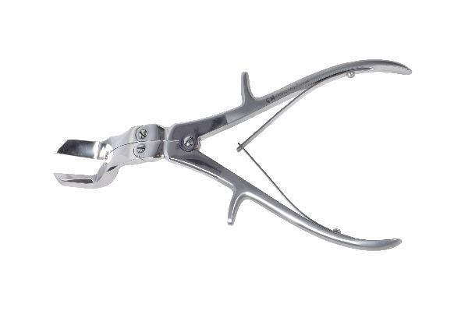
Function
The side-angled, hardened blades approach the rib parallel to the chest wall while the surgeon's hands remain safely above the operative field. Double-action leverage drives the sharpened edges through the rib cortex in one controlled stroke, producing a clean transection with minimal splintering of the costal bone ends.
Advantages
Angled Working Clearance: The offset jaw angle lets the blades engage ribs flush with the thoracic wall, improving access in deep-chested large breed dogs where straight forceps handles would collide with the ribcage.
Powerful Clean Shear: Double-action leverage drives the sharpened edges through dense costal bone in one controlled stroke, leaving smooth cut surfaces that reduce post-thoracotomy intercostal nerve irritation during recovery.
FAQ
Q: What procedures use Tudor-Edwards forceps most often?
A: Rib resection for thoracotomy access, rib graft harvesting for mandibular or nasal reconstruction, and trimming bone in chest-wall and spinal approach procedures.
Q: Why choose angled jaws over straight bone cutters?
A: Straight cutters need vertical clearance above the bone; angled jaws work parallel to curved surfaces like the rib cage, providing safe access in confined thoracic operative fields.

